|  |  |
| --- | --- |
| Roll. No. A016 | Name: Varun Mahendra Khadayate |
| Class B.Tech CsBs | Batch: 1 |
| Date of Experiment: 08-01-2022 | Date of Submission:08-01-2022 |

# Aim

Study all the topologies on Cisco Packet Tracer

## Bus Topology

Bus topology is a network type in which every computer and network device is connected to a single cable. It transmits the data from one end to another in a single direction. No bi-directional feature is in bus topology. It is a multi-point connection and a non-robust topology because if the backbone fails the topology crashes.

### Advantages of this topology:

* If N devices are connected to each other in a bus topology, then the number of cables required to connect them is 1, which is known as backbone cable, and N drop lines are required.
* The cost of the cable is less as compared to other topologies, but it is used to build small networks.

### Problems with this topology:

* If the common cable fails, then the whole system will crash down.
* If the network traffic is heavy, it increases collisions in the network. To avoid this, various protocols are used in the MAC layer known as Pure Aloha, Slotted Aloha, CSMA/CD, etc.
* Security is very low.

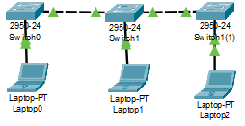

## Ring Topology

In this topology, it forms a ring connecting devices with its exactly two neighboring devices.

A number of repeaters are used for Ring topology with a large number of nodes, because if someone wants to send some data to the last node in the ring topology with 100 nodes, then the data will have to pass through 99 nodes to reach the 100th node. Hence to prevent data loss repeaters are used in the network.

The transmission is unidirectional, but it can be made bidirectional by having 2 connections between each Network Node, it is called Dual Ring Topology.

### The following operations take place in ring topology are :

1. One station is known as a monitor station which takes all the responsibility to perform the operations.
2. To transmit the data, the station has to hold the token. After the transmission is done, the token is to be released for other stations to use.
3. When no station is transmitting the data, then the token will circulate in the ring.
4. There are two types of token release techniques: Early token release releases the token just after transmitting the data and Delay token release releases the token after the acknowledgment is received from the receiver.

### Advantages of this topology:

* The possibility of collision is minimum in this type of topology.
* Cheap to install and expand.

### Problems with this topology:

* Troubleshooting is difficult in this topology.
* The addition of stations in between or removal of stations can disturb the whole topology.
* Less secure.

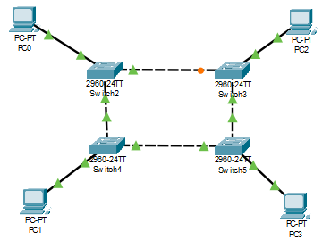

## Mesh Topology

In a mesh topology, every device is connected to another device via a particular channel.

* Suppose, N number of devices relate to each other in a mesh topology, the total number of ports that are required by each device is N-1. The total number of ports required by each device is 4. Total number of ports required=N*(N-1).
* Suppose, N number of devices relate to each other in a mesh topology, then the total number of dedicated links required to connect them is NC2 i.e., N(N-1)/2. In Figure 1, there are 5 devices connected to each other, hence the total number of links required is 5*4/2 = 10.

### Advantages of this topology:

* It is robust.
* The fault is diagnosed easily. Data is reliable because data is transferred among the devices through dedicated channels or links.
* Provides security and privacy.

### Problems with this topology:

* Installation and configuration are difficult.
* The cost of cables is high as bulk wiring is required, hence suitable for less number of devices.
* The cost of maintenance is high.

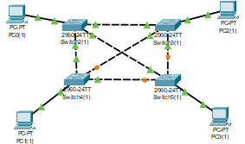

## Tree Topology

A tree topology is a special type of structure where many connected elements are arranged like the branches of a tree. For example, tree topologies are frequently used to organize the computers in a corporate network, or the information in a database.

### Advantages of Tree Topology :

* This topology is the combination of bus and star topology.
* This topology provides a hierarchical as well as central data arrangement of the nodes.
* As the leaf nodes can add one or more nodes in the hierarchical chain, this topology provides high scalability.
* The other nodes in a network are not affected, if one of their nodes get damaged or not working.
* Tree topology provides easy maintenance and easy fault identification can be done.
* A callable topology. Leaf nodes can hold more nodes.
* Supported by several hardware and software vendors.
* Point-to-point wiring for individual segments.

### Disadvantages of Tree Topology :

* This network is very difficult to configure as compared to the other network topologies.
* Length of a segment is limited & the limit of the segment depends on the type of cabling used.
* Due to the presence of large number of nodes, the network performance of tree topology becomes a bit slowly.
* If the computer in first level is erroneous, next level computer will also go under problems.
* Requires large number of cables compared to star and ring topology.
* As the data needs to travel from the central cable this creates dense network traffic.
* The Backbone appears as the failure point of the entire segment of the network.
* Treatment of the topology is pretty complex.
* The establishment cost increases as well.
* If the bulk of nodes are added in this network, then the maintenance will become complicated.

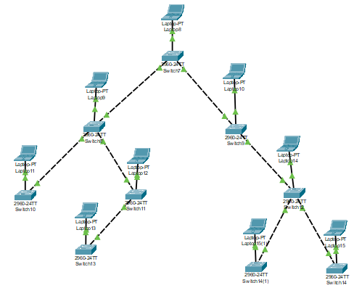

## Star Topology

In star topology, all the devices are connected to a single hub through a cable. This hub is the central node, and all other nodes are connected to the central node. The hub can be passive in nature i.e., not an intelligent hub such as broadcasting devices, at the same time the hub can be intelligent known as an active hub. Active hubs have repeaters in them.

### Advantages of this topology:

* If N devices are connected to each other in a star topology, then the number of cables required to connect them is N. So, it is easy to set up.
* Each device requires only 1 port i.e., to connect to the hub, therefore the total number of ports required is N.

### Problems with this topology:

* If the concentrator (hub) on which the whole topology relies fails, the whole system will crash down.
* The cost of installation is high.
* Performance is based on the single concentrator i.e., hub.

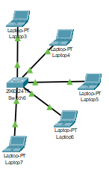

## Hybrid Topology

A hybrid topology is a type of network topology that uses two or more differing network topologies. These topologies can include a mix of bus topology, mesh topology, ring topology, star topology, and tree topology.

The choice to use a hybrid topology over a standard topology depends on the needs of a business, school, or the users. The number of computers, their location, and desired network performance are all factors in the decision.

### Advantages of Hybrid Topology:

* This type of topology combines the benefits of different types of topologies in one topology.
* Can be modified as per requirement.
* It is extremely flexible.
* It is very reliable.
* It is easily scalable as Hybrid networks are built in a fashion which enables for easy integration of new hardware components.
* Error detecting and troubleshooting is easy.
* Handles large volume of traffic.
* It is used for creating large network.

### Disadvantages of Hybrid Topology:

* It is a type of network expensive.
* Design of a hybrid network is very complex.
* There is change hardware in order to connect topology with another topology.
* Usually hybrid architectures are usually larger in scales so they requires a lot of cables in installation process.
* Hubs which are used to connect two distinct networks, are very costly. And hubs are different from usual hubs as they need to be intelligent enough to work with different architectures.
* Installation is a difficult process.

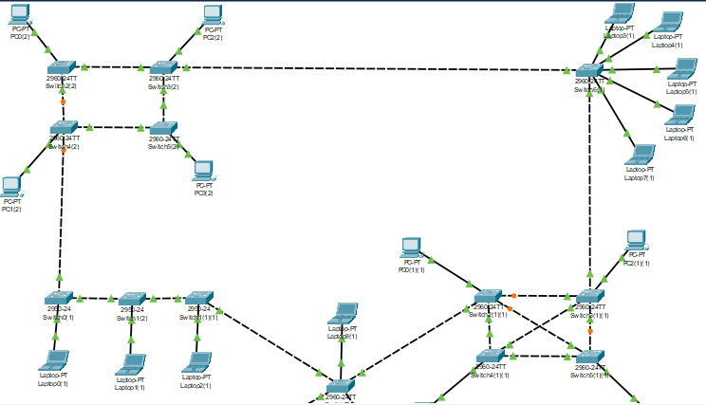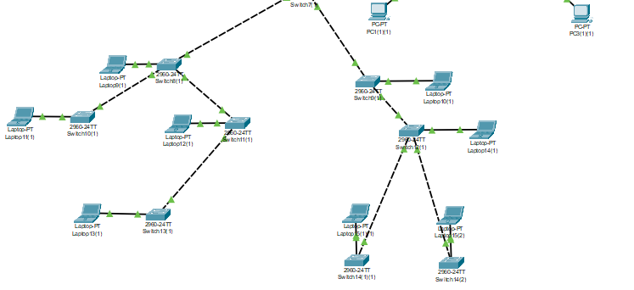

# Conclusion

Hence we were able to perform all the 6 topology in Cisco Packet Tracer